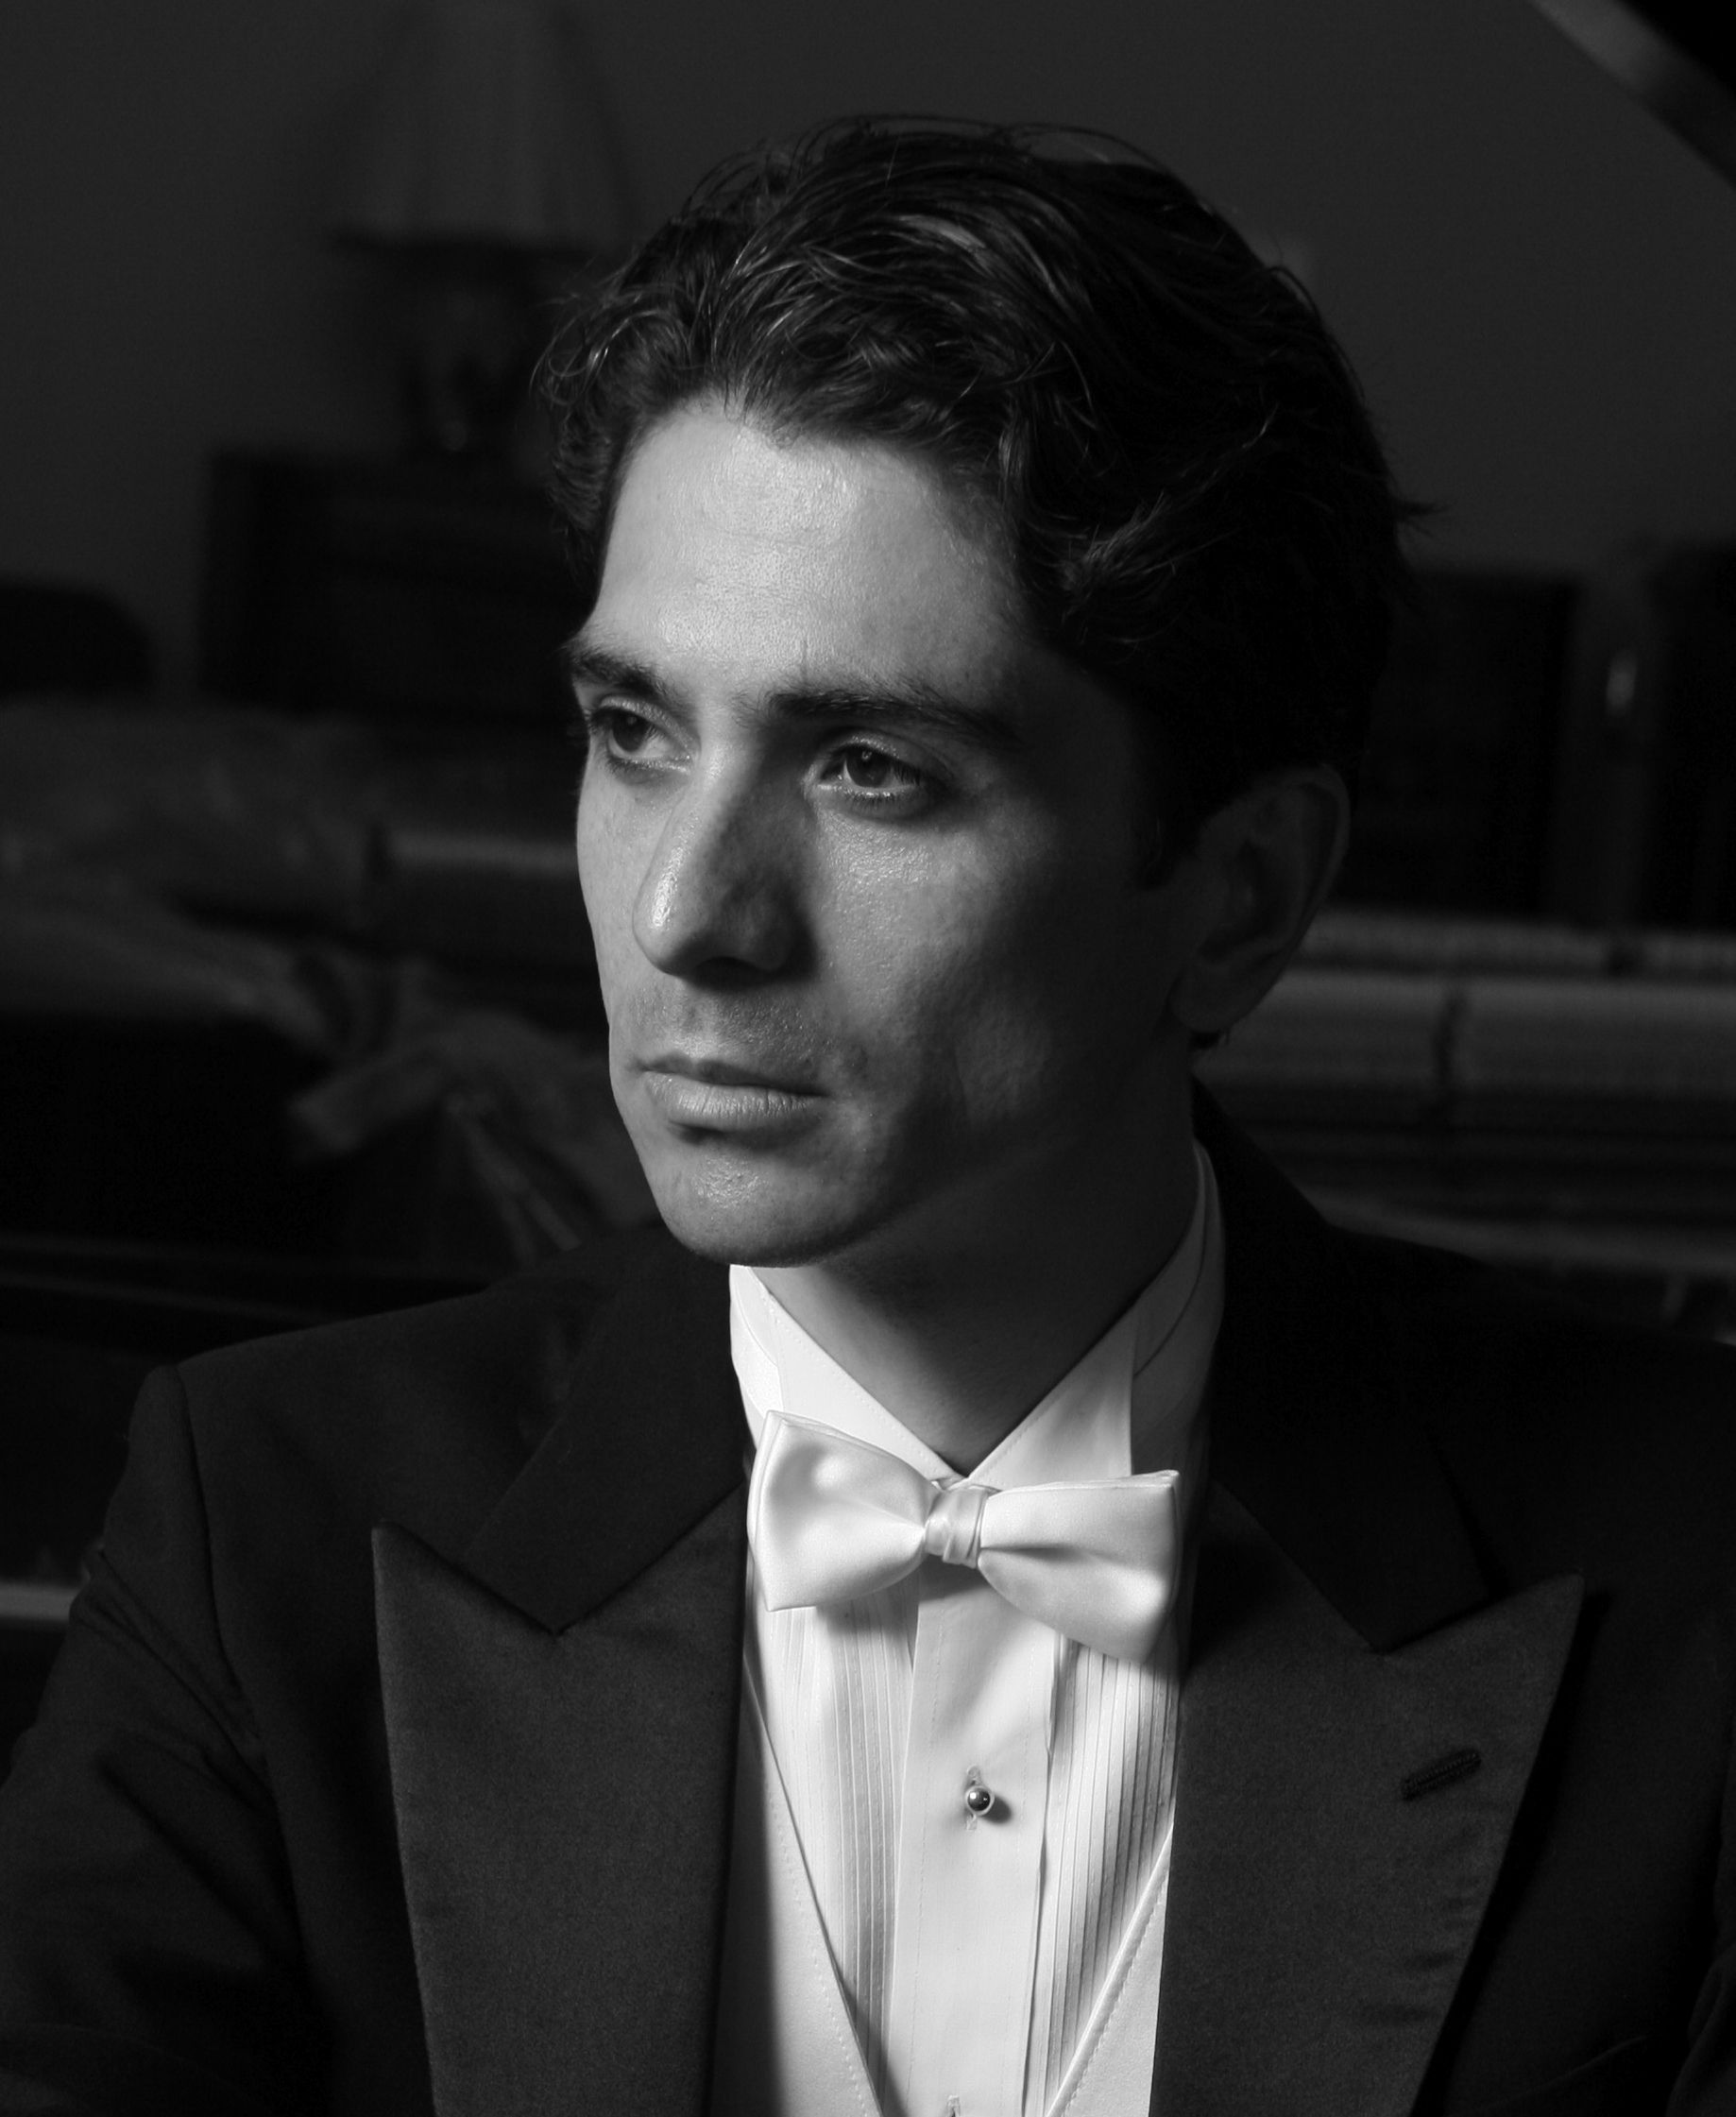

alexandros
KAPELIS

BIOGRAPHY (full version) - 953 words -

Born of a Greek father and a Peruvian mother, Alexandros Kapelis grew up in both countries and enjoys the advantages of a multicultural heritage. He began playing the piano when he was five years old and at the age of 20 he moved to New York, where early in his career he was recognized by the International Press Service (IPS) as “one of the most promising young classical musicians of any nationality working in New York today.” The Washington Post also praised him for his “scintillating performance,” whereas the Piedmont Post (San Francisco) noted him for his “full range of technique in rendering the total palette of keyboard colours.” He came to the attention of Martha Argerich and in 2007 he moved to Brussels, where he spent four years near the great pianist and participated in several editions of the Lugano Martha Argerich Project. He has appeared throughout Europe, the United States, Latin America, the Middle East, and Japan.

As a soloist, Kapelis’ highlights include appearances with the Royal Philharmonic Orchestra in London, the Prague Symphony Orchestra, and the Orchestre Symphonique de Toulon, amongst others. A prolific chamber music player, collaborations include performances with violinist Renaud Capuçon, violist Yuri Bashmet, cellist Mischa Maisky, clarinetist Stanley Drucker, trumpeter Sergei Nakariakov, pianist Martha Argerich, as well as ensembles from the Philharmonia Orchestra and the New York Philharmonic (Philharmonic Chamber Soloists). As a recitalist, Kapelis made his mark with an unprecedented programme on the Greek Myth seen through the piano repertoire. This programme took him to venues such as the Kennedy Centre in Washington, the Herbst Theatre in San Francisco, the Chicago Cultural Centre, the Centro Nacional de las Artes in Mexico City, the Salle Cortot and UNESCO in Paris, the Lugano Festival, a recital tour through Japan, and more recently, the leading Italian venues, including the Parco della Musica (Rome), Auditorium LaVerdi (Milano), Teatro della Pergola (Florence), Politeama Garibaldi (Palermo), Teatro Olimpico (Vicenza), and Palazzo Labia - RAI Veneto (Venice). Unanimously acclaimed by the press as a programme created by “an artist of genius” (Giornale di Vicenza) and “a pianist building a career of mythic proportions” (Oakland Tribune), Kapelis’ “Greek Myth Recital” was chosen for the transfer-of-power ceremony of the Presidency of Council of the European Union in 2014, in the presence of the Italian and Greek Presidents of the Republic and the Council of Ministers of both countries.

Currently, Kapelis has started a collaboration with the acclaimed ensemble of the Berlin Philharmonic, the Berliner Barock Solisten. They are currently recording the Complete Bach Concertos for keyboard and orchestra. This landmark project will take them on a world tour through 2021 and 2022, starting in London’s Barbican Hall (June 2021), followed by ten cities in Asia (November-December 2021), Europe (March and May, 2022) and the United States, Canada and Mexico (November-December 2022). In 2021, Kapelis also performs in China for the season opening of the Shaanxi Performing Arts Center, and in September with Martha Argerich (Poulenc Concerto for two Pianos and the Xi’an Symphony Orchestra). On the occasion of the 200th Anniversary of the independence of Greece, Kapelis will also perform his acclaimed Greek Myth Recital in the world’s leading museums that house the largest collections of Greek works of art from classical antiquity, bringing to life the legendary sculptures, mosaics, pottery and artefacts.

Off stage, Alexandros is known for his understanding of a wide range of subjects that have allowed him to bridge music with history, the visual arts, cultural identity, and the environment. In this capacity, he has acted as Artistic Director / Artistic Advisor for various institutions. In 2016, he teamed up with French cultural icon Pierre Cardin as Artistic Director of a miniseries at the Pierre Cardin Festival de Lacoste, an association that continues to this date. He has also collaborated with the Athens Megaron on their chamber music series and has been given the title of Artist in Residence in Venice with the mandate to develop and lead an international music festival in Venice, set to debut in September of 2021.

Alexandros Kapelis holds a Bachelor’s degree from the American College of Greece, and a Master’s degree from the Mannes College of Music in New York. His main teachers have been Rosa Basurco in Peru, Dimitri Toufexis in Greece, Diane Walsh and Julius Levine in New York, and Noretta Conci and Gwenneth Pryor in London. He also studied orchestral conducting at the masterclasses of Bruno Aprea (Rome Arts Academy) and Gianluigi Gelmetti (Accademia Chigiana). He conducted Handel’s opera Giulio Cesare at the Ernen Festival and nowadays leads Bach and Mozart piano concertos from the keyboard.

Since early in his career, Alexandros Kapelis has been involved with various humanitarian causes. He has performed in numerous benefit concerts, most notably in London for Fight for Sight (the leading UK charity dedicated to pioneering eye research), in New York for the United World Colleges (headed by HRH Prince Pavlos of Greece), and in Athens for ELEPAP (Greek Society for the Protection and Rehabilitation of the Disabled). The environment is also a cause close to Kapelis’ heart; under the patronage of UNESCO, in 2018 he founded PROJECT ECO (Earth Connections Orchestra), an initiative that combines music and the environment. On a personal note, Alexandros Kapelis founded “The Greco-Latin Trust” in order to help young musicians from countries facing economic difficulties, specifically Greece and Latin America. Inspired by his own years as a student in New York, where he had to face the challenges of supporting himself while pursuing a full-time Master’s programme, the Trust provides a living stipend to a full-time piano student for a year, in addition to offering performance opportunities.

Alexandros Kapelis is a Steinway Artist. He lives between Venice and London.

JUNE 2020: PLEASE, DISREGARD ANY PREVIOUSLY DATED VERSIONS • DO NOT EDIT OR MODIFY WITHOUT PERMISSION.

BIOGRAPHY (medium-length version) - 479 words -

Born of a Greek father and a Peruvian mother, Alexandros Kapelis began playing the piano when he was five years old. His main teachers have been Rosa Basurco in Peru, Dimitri Toufexis in Greece, Diane Walsh and Julius Levine in New York, and Noretta Conci and Gwenneth Pryor in London. He graduated with a Bachelor’s degree from the American College of Greece and a Master’s degree from the Mannes College of Music in New York. At the age of 20 he moved to New York, where early in his career he was recognized by the International Press Service (IPS) as “one of the most promising young classical musicians of any nationality working in New York today.” The Washington Post also praised him for his “scintillating performances,” whereas the Piedmont Post (San Francisco) noted him for his “full range of technique in rendering the total palette of keyboard colours.” He came to the attention of Martha Argerich and in 2007 he moved to Brussels, where he spent four years near the great pianist and participated in several editions of the Lugano Martha Argerich Project.

He has appeared throughout Europe, the United States, Latin America, the Middle East, and Japan, including as soloist with the Royal Philharmonic Orchestra in London and the Prague Symphony Orchestra. Chamber music collaborations include Renaud Capuçon, Yuri Bashmet, Mischa Maisky, Stanley Drucker, Sergei Nakariakov, and Martha Argerich, as well as ensembles from the Philharmonia Orchestra and the New York Philharmonic (Philharmonic Chamber Soloists). As a recitalist, Kapelis made his mark with his “Greek Myth” programme in venues such as the Kennedy Center, the Herbst Theatre, the Chicago Cultural Center, the Centro Nacional de las Artes in Mexico City, the Salle Cortot, UNESCO, the Lugano Festival, and the main Italian theatres.

Currently, Kapelis is recording the complete Bach solo keyboard concertos with the acclaimed ensemble of the Berlin Philharmonic, the Berliner Barock Solisten, with upcoming performances in London’s Barbican Hall (June 2021), Asia (November-December 2021), Europe (March and May 2022) and the USA, Canada and Mexico (November-December 2022).

Off stage, Kapelis has acted as Artistic Director/Advisor for various institutions. In 2016, he teamed up with French cultural icon Pierre Cardin for a series at the Pierre Cardin Festival de Lacoste. He has also collaborated with the Athens Megaron on their chamber music series and has been given the title of Artist in Residence in Venice, to lead an upcoming international music festival in Venice. Kapelis has supported various humanitarian causes that include medical research, education, and people with disabilities. In 2016, he also founded PROJECT ECO, an initiative under the patronage of UNESCO that combines music and the environment. Inspired by his own financial challenges as a student in New York, he also founded “The Greco-Latin Trust” to help young musicians from countries facing economic difficulties, specifically Greece and Latin America. Alexandros Kapelis is a Steinway Artist.

JUNE 2020: PLEASE, DISREGARD ANY PREVIOUSLY DATED VERSIONS • DO NOT EDIT OR MODIFY WITHOUT PERMISSION.

BIOGRAPHY (short version) - 282 words -

Born of a Greek father and a Peruvian mother, Alexandros Kapelis has appeared throughout Europe, the United States, Latin America, the Middle East, and Japan, including as soloist with the Royal Philharmonic Orchestra in London and the Prague Symphony Orchestra. Early in his career he was recognized by the International Press Service (IPS) as “one of the most promising young classical musicians of any nationality working in New York today.” Chamber music collaborations include Renaud Capuçon, Yuri Bashmet, Mischa Maisky, Stanley Drucker, Sergei Nakariakov, and Martha Argerich, as well as ensembles from the Philharmonia Orchestra and the New York Philharmonic and several editions of the Lugano Martha Argerich Project. As a recitalist, Kapelis made his mark with his “Greek Myth” programme in venues such as the Kennedy Centre, the Herbst Theatre, the Chicago Cultural Centre, the Centro Nacional de las Artes in Mexico City, the Salle Cortot, UNESCO, the Lugano Festival, and the main Italian theatres.

Currently, Kapelis is recording the complete Bach solo keyboard concertos with the acclaimed ensemble of the Berlin Philharmonic, the Berliner Barock Solisten, with upcoming performances in London’s Barbican Hall and Asia in 2021, and Europe, the USA, Canada and Mexico in 2022.

As Artistic Director/Advisor, Kapelis has collaborated with French cultural icon Pierre Cardin at the Lacoste Festival, the Athens Megaron on their chamber music series, and was given the title of Artist in Residence in Venice to lead an upcoming international music festival. He has supported various humanitarian causes that include the environment with PROJECT ECO (under the patronage of UNESCO), and education through “The Greco-Latin Trust,” which he founded to help young musicians from Greece and Latin America. Alexandros Kapelis is a Steinway Artist.

JUNE 2020: PLEASE, DISREGARD ANY PREVIOUSLY DATED VERSIONS • DO NOT EDIT OR MODIFY WITHOUT PERMISSION.

www.kapelis.co

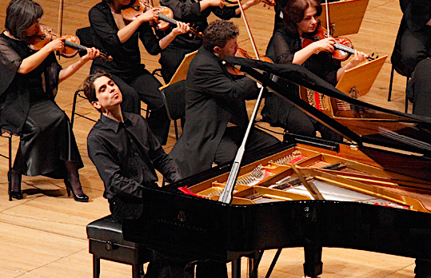

alexandros
KAPELIS

REVIEW EXCERPTS

“Kapelis threw himself forcefully into the wild raptures of Claude Debussy's "The Joyous Island" and expertly limned the classical poise of his "Dancers of Delphi.”
THE WASHINGTON POST (Washington, D.C.)

“There is in his playing a precision of rhythm, a dedication to clarity and a clear attentiveness to form. One can almost see him listening to the composer’s voice. This was especially obvious in the concluding piece of the programme, Rachmaninoff’s Études-Tableaux, Op. 33. Closest to Kapelis’ essence as a musician, these miniature tone poems require dramatic expressiveness, but it is an expressiveness best served by containment and control… Kapelis engaged that challenge with a driving energy, under which must beat a passionate heart.”
PIEDMONT POST (San Francisco)

“A rarity among his generation, Kapelis plays expressively and evocatively. His emotional and psychological explorations into music make him one of the most promising young classical musicians of any nationality in New York today. “
INTERNATIONAL PRESS SERVICE- IPS (New York)

“Kapelis possesses as undeniable temperamental vein and a dominion over the Lutoslawski Paganini Variations for piano and orchestra. This work is full of mortal difficulties, even for such a well-equipped instrumentalist. Kapelis overcame all these traps with great success.”
EL PORVENIR (Monterrey, Mexico)

“Kapelis does not indulge aimlessly from one note to the other, neither does he linger unnecessarily. Thus, he sounds neither vulgar nor flashy. On top of that, he masters lyricism and passion convincingly and with bravura.”
THE ORIZZONT (Valetta, Malta)

“The performance of the Schumann piano concerto responded to the passionate impulse that echoed in the youth of Alexandros Kapelis, exulting the lyricism and the dialogue between the piano and the orchestra. The soloist took advantage of his technique, energy and vitality, qualities that augur him a brilliant future in his musical career. “
EL COMERCIO (Lima, Peru)

“Kapelis proved to be a well-schooled performer of Scarlatti, achieving the always-difficult adaptation from the current piano to the baroque clavicembalo. The artist once more was faithful to the pristine text... Kapelis displayed his traits as a virtuoso of the keyboard, without any concession to the public nor to decadent sentimentality.”
DIARI DE BALEARS (Mallorca, Spain)

“It is needless to point out the huge demands that Mozart places on the performer regarding maturity of expression, stylistic fidelity, cleanliness, and structural balance. Even so, Kapelis passed this “trial by fire” with an ease that truly impressed us. With his clean, sure technique, with his evenness, and especially with his correct weight of sound (so it would not overpower but neither fall into “angelic sweetness”), Kapelis created an interpretation that displayed not only his pianistic talent, but also his indisputable expressive maturity.”
ESTIA (Athens, Greece)

“Robust, of a brilliant virtuosity, but also stylistically attentive, was the interpretation of Alexandros Kapelis. [Mendelssohn Quartet for piano & strings, Op. 3]”
KATHIMERINI (Athens, Greece)

“It was moving to listen to Greek pianist Alexandros Kapelis, a fully structured musician with strength and sensitivity, but also with ethos, revealed not only by the quality of his sound, but also by his bearing and body language. Last night, he stood worthily on stage next to the great Martha Argerich in Bach’s Concerto [BWV 1065].”
KATHIMERINI (Athens, Greece)

"Kapelis has no equal in Rachmaninoff, but he also plays the classics with astonishing taste."
MARTHA ARGERICH, Interview in "Classica"

www.kapelis.com

